**SUPERIOR UNIVERSITY LAHORE**

|  |
| --- |
| Superior Logo |

**Faculty of Computer Science & IT**

**Game Programming**

**Final Term Report**

**Project Team**

|  |  |  |  |  |
| --- | --- | --- | --- | --- |
| **Student Name** | **Student ID** | **Program** | **Contact Number** | **Email Address** |
| Asadullah Shahid | BCSM-F17-097 | BSCS |  | bcsm-f17-097@superior.edu.pk |
| Mustafa Manzoor | BCSM-F17-091 | BSCS |  | bcsm-f17-091@superior.edu.pk |
| Adeel | BCSM-F17-074 | BSCS |  | bcsm-f17-074@superior.edu.pk |

**Introduction:**

Serious Games is a concept that uses gaming technology for education, marketing, communication and problem solving. Developers say these revolutionary methods help people learn difficult and complicated subjects in a simple and sometimes amusing way. More than 50 state-of-the-art producers and designers came together in the French city of Lyon to promote and inform. Sophie Romano organised the event: "When you feel an emotion, you learn more easily, it is easier to integrate the knowledge.

Play is an important vehicle because when we play, we have fun, its pleasurable, we win, we lose, we feel. So its an effective method." Artefacts Studio presented a number of educational innovations that teach children in a interactive and straightforward way. Handwashing may seem mundane but it is a vital way to stay healthy. Interaction Games have created an interactive game for professional orientation, which analyses how a player reacts to situations in a virtual village.

Emmanuel Guardiola is the creative director of the French company Seaside: "A lot of possibilities are hidden in the village, for example we can discover fungi. Will the gamer find out? Will they be interested? Will it spread and change the way the village looks ? Will the gamers use this as a tool to change the way they navigate around the village? All the data is compiled and it provides a psychological profile and help career development." An engineering school in Paris has developed an affordable vision headset called Oculus, which allows total immersion in the virtual world.

Here the user has to manipulate the environment in a series of complex hand movements, which could be used to train pilots, surgeons and engineers. Jphd360 showcased an immersion project, which situates a player in a situation. Graphics and body movement makes the player feel like they are really there. Isabelle Fournot is a Serious Games developer: "This game has been designed to allow families to save energy in their homes.

They are immersed in a real home. A motion detector is used to interact with the images. The fridge needs to be full, an empty fridge consumes too much energy. A mixer should be used with the taps to save hot water and for cooking the pan must fit the hot plate and have a lid to save on power." First aid games are a vital new teaching tool. French company Les Atelier Numeriques have a game that shows what to do if someone nearby suffers a stroke. Panic is the norm, but the games shows people just what to do before the doctor arrives. It could be a life saver.

**7 steps effective serious game gamification implementation:**

1. “Required” works best.

#### 2. Blend into a curriculum: use as *part*of a learning solution.

#### 3. Use the game as a reinforcement (most of the time).

#### 4. Offer incentives and/or provide sufficient motivation.

#### 5. Create a communications strategy around the game.

#### 6. Use reporting and adapt the training.

#### 7. Gather insights via surveys.

**Flappy Bird:**

* **This game is HARD.** It took me at least 10 minutes before I even made it past the first pair of pipes. And it’s not just me who finds the game difficult. Other folks have taken to Twitter to complain about Flappy Bird. They say the game is so difficult, that the physics must be WRONG.
* Then I imported the videos into Logger Pro and did a typical video analysis by tracking Flappy’s vertical position in the video. Sure enough, the upside-down parabolic curves indicate Flappy is undergoing downward acceleration.

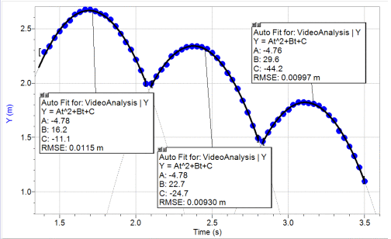

* But do the numerical values represent normal Earth-like gravity or insanely hard Jupiter gravity? In order to do this, we need to (1) set a scale in the video so that Logger Pro knows how big each pixel is in real life and (2) determine the slope of Flappy’s velocity-time graph while in free fall, which is equal to the gravitational acceleration.
* The only thing we could realistically assume is the size of Flappy Bird. If we assume he’s as long as a [robin](http://en.wikipedia.org/wiki/American_Robin) (24 cm), then the slope of the velocity-time graph is **9.75 m/s/s**, which is really close to Earth’s gravitational acceleration of 9.8 m/s/s. **Flappy Bird is REAL LIFE**.

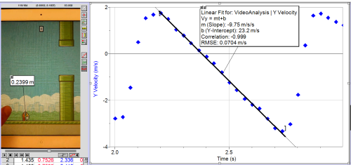

So then why is everyone complaining that the game is unrealistic when, in fact, it is very realistic? I blame Angry Birds and lots of other video games. Repeating the same video analysis on Angry Birds and assuming the red bird is the size of a robin (24 cm), we get a gravitational acceleration of 2.5 m/s/s, which only 25% of Earth’s gravitational pull.

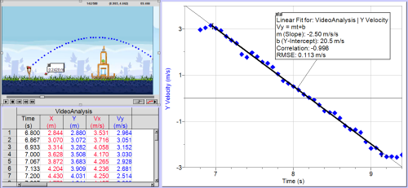

In order to make Angry Birds more fun to play, the programmers had to make the physics less realistic. People have gotten  used to it, and when a game like Flappy Bird comes along with realistic physics, people exclaim that it must be wrong. As one of my students notes: